# CS 340 README Template

Janera Dobson

CS-340-X2142

*Use this template to complete your README file. When completing the template, keep the headings as they are so that your document has a clear organization. Remove the italicized prompt text after you have completed each section for a polished final document.*

## About the Project/Project Title

Animal Shelter: I work for a company called Global Rain, a software engineering company that specializes in custom design and development. I was asked by an innovative international rescue-animal training company, Grazioso Salvare to develop a full stack software application that can work with existing data from the animal shelters to identify and categorize available dogs.

## Motivation

The motivation behind the creation and maintenance of the project is to help Grazioso Salvare, to have a full stack development application that will include a database and a client-facing web application dashboard, through with users at Grazioso Salvare will access the database. The project will be open source and accessible on GitHub, so similar organizations can adapt to it.

## Getting Started

To get a local copy up and running, follow these simple example steps:

* Start mongo with /usr/local/bin/mongod_ctl start
* Change directory to cd/usr/local/datasets
* Copy port number given from the previous output
* Then code: mongoimport –port ##### --db AAC –collection animals –type=csv –headerline ./aac_shelter_outcomes.csv

## Installation

* Terminal
* A Python IDE
* Jupyter Notebook
* Although from a terminal you can access Jupyter Notebook with will allow you to code .py and .ipynb files

## Usage

CRUD is an acronym used by computer programmers which stands for:

* C: Create – function allows users to create a new record in a database.
* R: Read – function allows user to search and retrieve specific records in a database.
* U: Update – function allows users to modify existing records that exist in a database.
* D: Delete – function allows users to remove records from a database that is no longer needed.

### Code Example

#The import that allows for server connections to Mongo

from pymongo import MongoClient

#The import that allows for querying with an ObjectID

from bson.objectid import ObjectId

# The method to implement the C in CRUD.

def create(self, data):

#Checks to see if the data is null or empty and returns false in either case

if data is not None:

if data:

self.database.animals.insert_one(data)

return True

else:

return False

# The method to implement the R in CRUD.

def read(self, search):

#Checks to see if the data is null or empty and returns exception in either case

if search is not None:

if search:

searchResult = self.database.animals.find(search)

return searchResult

else:

exception = "Nothing to search, because search parameter is empty"

return exception

# The method to implement the U in CRUD.

def update(self, save):

if save is not None:

# the save() method updates the document if this has an _id property

# which appears in the collection, otherwise it saves the data

# as a new document in the collection

if save:

saveResult = self.database.animals.insert_one(save)

return saveResult

else:

exception = "Nothing to update, because save parameter is None"

# The method to implement the D in CRUD.

def delete(self, remove):

if remove is not None:

if remove:

removeResult = self.database.animals.delete_one(remove)

else:

exception: "Nothing to delete, because remove parameter is None"

### Tests

You must give the console test data to search for after implementing the C in CRUD

#Test data

data = {"age_upon_outcome": "5 months",

"animal_id": "A333333",

"animal_type": "Cat",

"breed": "Toyger",

"color": "Brown and Black",

"date_of_birth": "07/21/20",

"datetime": "2020-07-21 10:49:00",

"monthyear": "2020-07-21T10:49:00",

"name": "Arenaj",

"outcome_subtype": "Foster",

"outcome_type": "Adoption",

"sex_upon_outcome": "Spayed Female",

"location_lat": 33.60384687,

"location_long": -97.35033333,

"age_upon_outcome_in_weeks": 28.9642246428357}

### Screenshots

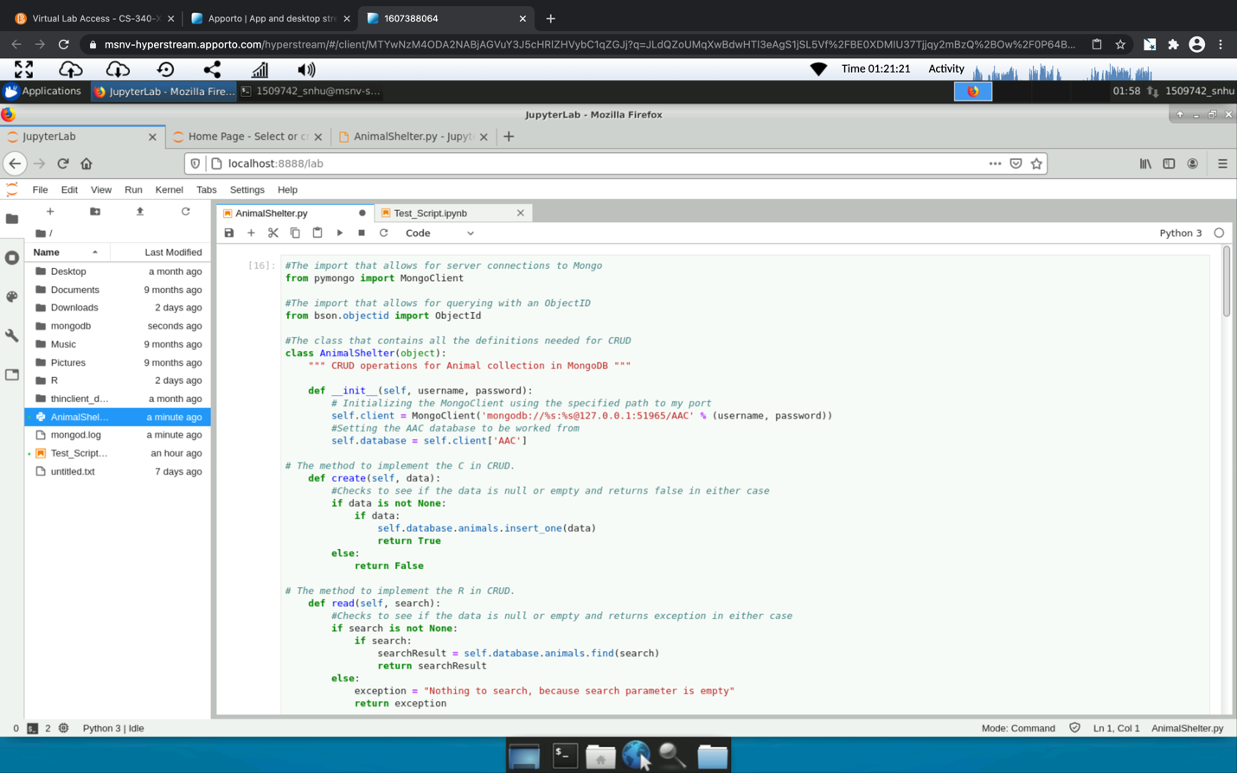

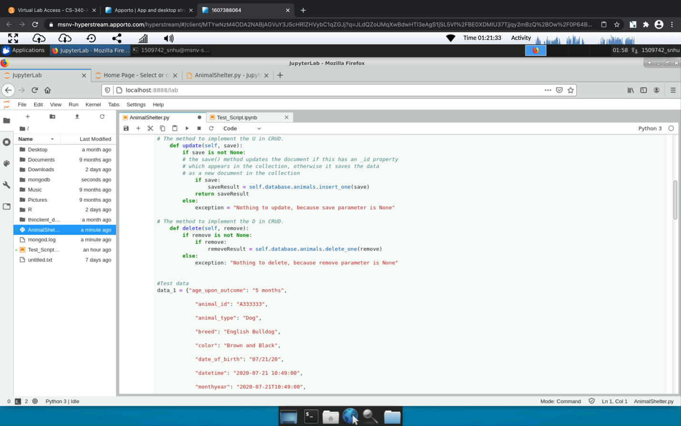

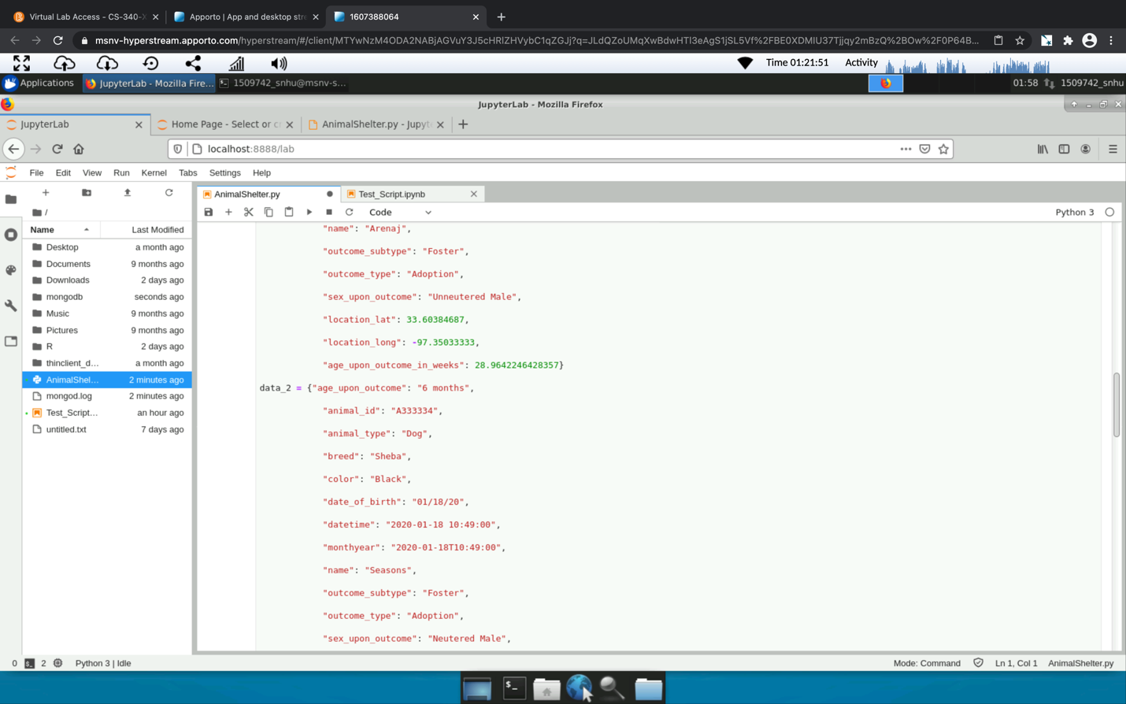

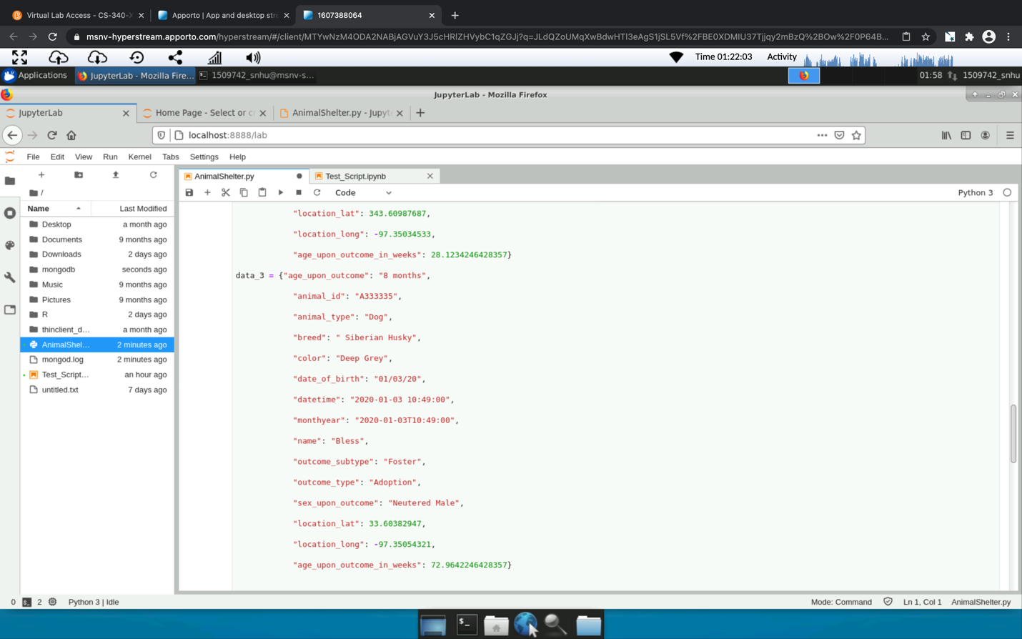

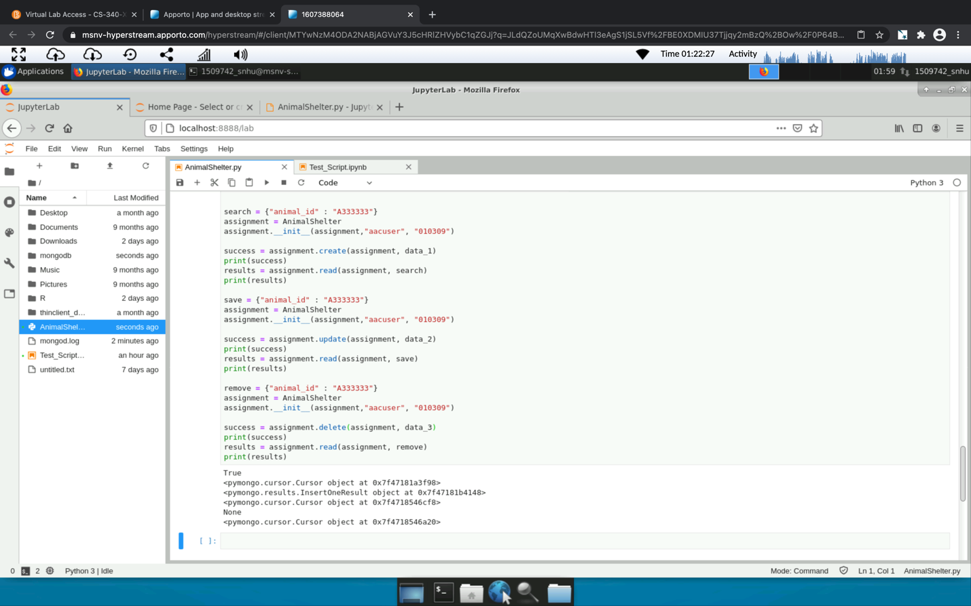

## Contact

Your name: Janera Dobson